|  |  |  |
| --- | --- | --- |
|  | Available online at www.sciencedirect.com |  |
|  |
| AASRI Procedia 3 ( 2012 ) 553 – 558 |

2012 AASRI Conference on Modeling, Identification and Control

Long-distance Electrochemical Interactions and Anomalous Ion Exchange Phenomenon

T.Jumadilova, B.Yermukhambetovab*, S.Panchenkob,c, I.Suleimenovc

*aInstitute of Chemical Sciences, 106 Valikhanova, Almaty 050100, Kazakhstan*   
*bKazakh National University, 71 Al-Farabi, Almaty 050038, Kazakhstan*   
*cAlmaty University of Power Engineering and Telecommunications, 126 Baitursynova, Almaty 050013, Kazakhstan*

**Abstract**

Click here and insert your abstract text.

© 2012 Published by Elsevier B.V. Selection and/or peer rev[iew under responsi](http://creativecommons.org/licenses/by-nc-nd/3.0/)bility of American Applied © 2012 The Authors. Published by Elsevier B.V. Open access under [CC BY-NC-ND license.](http://creativecommons.org/licenses/by-nc-nd/3.0/)   
Selection and/or peer review under responsibility of American Applied Science Research Institute

*Keywords*: proton donor, proton acceptor, distance interaction

**1.Introduction**

Electrochemical processes usually occur under condition of electric neutrality of a system as whole and its macroscopic parts separately. A set of electrochemical reactions may be quite complicated, but the deviations from neutrality usually have scale determined by Debye length only, i.e. known types of chemical processes cannot result in appearance of macroscopic electric charge and electric currents.

At the same time, appearance of macroscopic electric charge (as well as electric current of pronounceable magnitude) in biological systems is a result of chemical reactions. The most important example is electric activity of biological neuron networks.

Now we report that organic chemical reaction directly resulting in charging of a macroscopic specimen is observed. Non-zero macroscopic charge appears during long-distance interactions between two polymer

* Corresponding author. Tel.: +7-701-720-97-67;   
*E-mail address:* Baya_Yerm@mail.ru.

2212-6716 © 2012 The Authors. Published by Elsevier B.V. Open access under [CC BY-NC-ND license.](http://creativecommons.org/licenses/by-nc-nd/3.0/) Selection and/or peer review under responsibility of American Applied Science Research Institute doi: 10.1016/j.aasri.2012.11.087

554  *T.Jumadilov et al. / AASRI Procedia 3 ( 2012 ) 553 – 558*

hydrogels, when one network is a cross-linked polyacid, which generates moveable hydrogen ions, and another cationic hydrogel can take part in a chemical reaction of bonding of mentioned ions.

One should underline that hydrogels (polymer networks) were investigated intensively during last few decades [1-3]. This polymer material is of great interest mainly due to its pronounceable reaction on slight variation of external conditions. Hydrogels initially swelled in water up to very high degrees (1000 g/g and more) may change their volume sharply due to variation of temperature, ionic strengths of surrounding media, influence of electric current, etc.

Nowadays polymer hydrogels usually are considered as intelligent materials, and their advanced applications are developing in this way. In particular, different biomimetics and biomodeling applications are discussing widely in current literature [1-3].

Interactions between different types of hydrogels are much less investigated that hydrogels themselves; one can found only separate reports on this subject in current literature [4,5]. Besides, cited articles [4,5] are devoted to contact interactions of hydrogels. Now we report about sufficiently new phenomena, which demonstrate possibility of electrochemical interactions between specimens placed at quite long distance from each other.

**2.Experimental**

A polyethyleneymine (PEI) gel having =NH groups (gel-1) was placed at the bottom of cylindrical tube filled by distillated water (Fig.1) and cross-linked polyacrylic acid (PAA) was placed on the glass filter just above the first specimen under the upper level of water (gel-2). Gels were synthesized in the same manner as described in ref. [6].

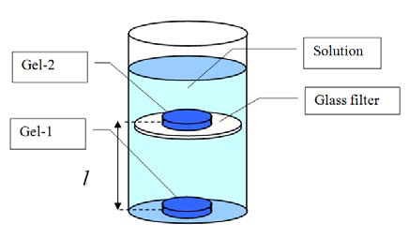

Fig. 1 experimental scheme

Initially both gels were swollen in distillated water up to equilibrium state. (Equilibrium swelling ratio in distilled water *K0* without interaction directly depends on the density of cross-linking; this parameter we will use to characterize different samples of polymer networks having the same chemical composition.)   
Swelling ratio K was calculated as ratio of volume of swelled specimento its volume in dry state. Volume was measured with the help of cathetometer (B-630, Russia, accuracy ±0.01 mm).

**3.Results**

The main visible result of long-distance interactions between gel-1 and gel-2 is an additional swelling, i.e. resulting swelling ratio of PAA gel is about 1.2-1.5 times higher than in pure water. The dependence of swelling ratio *K* of PAA gel on distance between specimens (from 1.0 up to 20.0 cm) is shown at Fig.2. Different curves correspond to different values of initial swelling ratio *K0*.

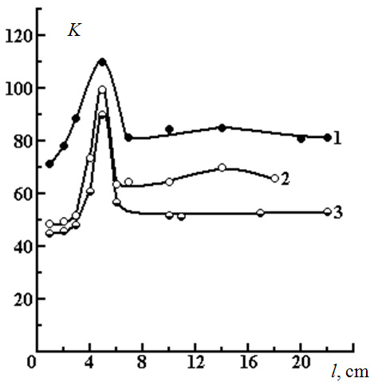

|  |  |
| --- | --- |
| *T.Jumadilov et al. / AASRI Procedia 3 ( 2012 ) 553 – 558*  Fig. 2. Dependencies of swelling ratio *K* of PAA gel on distance between PEI (gel 1) and PAA (gel 2) specimens; 0 (PAA) = 68,2 (1); | 555 |

45,5 (2); 32,4 (3); 0 (PEI) = 3,1

It is easy to see that obtained curve is non-monotonic one: additional swelling of PAA gel sufficiently depends on the distance *l*. Here we should underline that typically swelling ratio has maximum just in pure water (in comparison with other solvents). In particular, adding of salt or organic compounds leads to contraction of the specimen with releasing of water in surrounding solution. In other words, obtaining much higher swelling ratio is surprising fact as it is.

Long-distance interaction between polymer networks results in anomalous behavior of swelling ratio with increasing of salt concentration too (Fig.3). Normally the adding of salt leads to decreasing of swelling ratio [7-9]. Nevertheless, in our experiments swelling ratio increase in salt solution of relatively low concentration.

Thus, long-distance interactions between two polymer networks express itself in a number of surprising facts, which cannot be explained without consideration of electrochemical factors in details.

**4.Discussion**

*4.1.Long-distance interactions mechanism*

Pair of next reactions may explain long-distance interactions between two hydrogel specimens:

R1-COOH  R1-COO- + H**+** *(1)*

R2=NH + H**+** R2=NH2 **+** *(2)*

Normally reactions (1) and (2) do not break up the electric neutrality of a system, but in our case the first reaction takes place in volume of one specimen, and the other occurs in volume of specimen which is placed at relatively long distance. Hydrogen ions generated in volume of the first sample are chemically bonding by neighboring specimen. In other words, polyacrylic acid gel (reaction 1) may be considered as a donor, and the gel-2 as an acceptor of protons (reaction 2). Consequently, both gels obtain non-zero electrostatic charge (Fig 4), and behavior of the system now is determined by macroscopic charge distribution.

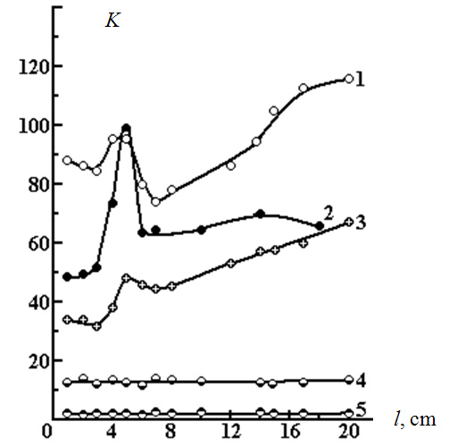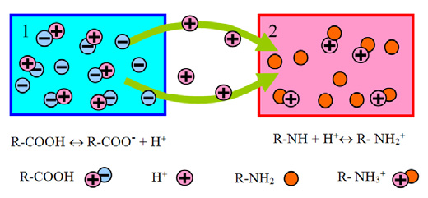

556  *T.Jumadilov et al. / AASRI Procedia 3 ( 2012 ) 553 – 558*

First, non-zero charge of each specimen leads to repulsion of charged functional groups of each gel from each other. It is necessary to underline, that charges of functional groups inside each gel actually is moveable. Their motion has the same mechanism as holes conductivity in semiconductors. A proton may disconnect from a –COOH group and join to neighbor dissociated –COO- group. Totally, such process may be considered as motion of –COO- charged “particle”. Repulsion of such negative particles leads to formation of a thin charged layer at surface of a specimen, which take part in long-distance interaction with acceptor of protons, while the degree of dissociation of weak carbon acid is low.

Fig. 3. The influence of ionic strength on swelling ratio *K* of PAA gel at long-distance interaction between PAA mad PEI networks; 0

|  |  |
| --- | --- |
| (PAA) = 45; | 0 (PEI) = 3; =0,001 (1); 0 (2); 0,01 (3); 0,1 (4); 0,5 (5) |

Fig. 4. Formation of macroscopic charge at long-distance interaction between acceptor and donor networks

Thin charged layer is forming at surface of gel-acceptor in the same way; surface electric layers of charged specimens form together a kind of capacitor. These oppositely charged layers attract to each other resulting in appearance of additional force stretched the network, which gives an additional swelling of the specimen as whole in accordance with the theory [10], previously developed for the case uniformly charged networks.

*T.Jumadilov et al. / AASRI Procedia 3 ( 2012 ) 553 – 558*  557

This additional force is relatively strong when the distance between specimens is short, and this force is obviously negligible when one specimen is placed quite far from another. Consequently, the dependence of additional swelling of hydrogel on distance *l* may be explained by peculiarity of non-compensated charge distribution only. Moreover, magnitude of electric field, which appears at the surface of a specimen involved in long-distance interaction is limiting factor of charging. Indeed, vector of electric field cross the surface in any case (when the specimen is fixed quite close to oppositely charged one, and when they are placed sufficiently far from each other too).

As well as in the case of classic swelling of polyelectrolyte hydrogel [11], this field plays a double role. First, it acts on charged particles concentrated near the surface of the specimen resulting in additional swelling. Second, the same action promote decomposing of =NH+ 2 groups and may tear out hydrogen ions, i.e. magnitude of the field restrict electric charge of both specimens. Obviously, this factor restrict total amount of ions involved in reaction (2) also.

Thus, a hydrogel pair of considered type obtains (*in idealized case*) non-zero macroscopic electric charge in pure water, which is restricting by its own surface density.

*4.2.Anomalous ion exchange phenomenon*

We will consider the case when low-molecular electrolyte, potassium chloride, for example, is added in solution surrounding both gels. Obviously, negative ions will be attracted to positively charged gel, and positive ones – to PAA gel.

Next reaction may present such process schematically:

R1-COO- + R2=NH2 **+** + NaCl  R1-COONa + R2=NH2Cl  *(3)*

Low-molecular ions are separated between hydrogel pair in this reaction (3); besides, low-molecular salt is removed from solution into gel pair volume, i.e. anomalous ion exchange actually takes place. Normally reaction (3) *cannot take place at all*, but in the case of long-distance interactions between hydrogels it became quite understandable. Indeed, reaction (3) is a total of two different processes, which take place in different specimens.

We should underline that such ion exchange is namely anomalous one, while during reactions gathered by scheme (3) in PAA gel volume takes place the process correspond to next ion exchange reaction:

R1-COOH + Na**+** R1-COONa +H**+**  *(4)*

Normally such ion exchange reaction occurs in opposite direction, while degree of dissociation of R1-COOH groups is much less than degree of dissociation of R1-COONa groups.

Macroscopic electric charge of both samples after process (3) is likely to be compensated if total amount of low-molecular ions in solution is enough, and electric field will be close to zero. Nevertheless one should take into account, that decreasing of eclectic field moves off the factor, which restricted total amount of protons involved in reaction (2). Consequently, an additional portion of hydrogen ions may be bonded by R2=NH groups. This ions give new charge to =NH-gel, which, obviously may be compensated by low-molecular ions if their total amount in solution is enough, etc. Thus, the reaction (4) may take place until all hydrogen ions will be changed by potassium ions.

Fig. 2 represents direct experimental evidence of anomalous ion exchange phenomenon. Namely, it is well known [11], that polymer networks based on carbon acids may demonstrate respectively low swelling ratio due to low degree of dissociation of weak polyacid (30-80 g/g for typical specimens). On the contrary, degree of dissociation of the same gel in the salt form (R1-COONa) is much higher (100-900 g/g, [1,2,11, 12]). Curve 1 at Fig. 2 corresponds to product of reaction of anomalous ion exchange, while swelling ratio reach values, which are normal for gel in salt form and never can be obtained for acid gel of used type.

558  *T.Jumadilov et al. / AASRI Procedia 3 ( 2012 ) 553 – 558*

Further increasing of salt concentration in surrounding solution leads to decreasing of swelling ratio, as well as this effect takes place for any polyelectrolyte gel is salt form usually. Such decreasing of swelling ratio corresponds to curves 4-5 at Fig.2.

The most obvious applications of observed phenomenon lie practically in the same field that for ion exchange (water purification, enrichment technologies, etc). Nevertheless, anomalous ion exchange has some sufficient preferences. First, the ionic exchange system based on phenomenon of long-distance interactions between hydrogels is easy renewable. Indeed, it is enough to apply mechanical stress for releasing concentrated salt solution. Second, anomalous ion exchanging gives possibility to get out arbitrary salt from solution, etc.

Besides, described phenomenon allows understanding the mechanism of ion transport in opposite direction in respect to sign of chemical potential gradient. It is well known, that such transportation often takes place in biological systems.

**5.Conclusions**

Thus, one can say that interactions between acid and protonized polymer hydrogels demonstrate an example of chemical process, which results in appearance of macroscopic electric charge. Generally, this charge may be considered as a chemical signal, which can propagate for a quite long distance and used for artificial neuron networks development in future. Other applications of observed phenomena are connected with anomalous ion exchange, for example for deep purification of water solutions from low-molecular salts.

**References**

[1] Radeva T. Physical chemistry of polyelectrolytes. NY, Marcel Dekker, Inc. 2001. 211 p.

[2] Osada Y., Gong J. P., Sawahata K. Synthesis, Mechanism, and Application of Electro-Driven Chemomechanical System Using Polymer Gels, J. Macromol. Sci.-Chem., 1991, A28, 1189.

[3] Phillipova O. Responsive polymer gels. Polymer Science, 2000, 42, #2, 208.

[4] Kokufuta E., Ogawa K., Miyake M. Polyelectrolyte complex formation between anionic and cationic nanogels in salt-free aqueous solution // Abstr. 6th Int. Symp. “Polyelectrolytes”, Dresden, 2006.

[5] Karpushkin E.A., Kechek’yan A.S., Zezin A.B. Interpolyelectrolyte reaction between the particles of oppositely charged microgels, Polymer Science, 2006. B48, 301   
[6] Ismailova Sh., Jumadilov T., Bekturov E. Peculiarities of complex formation between polyacrylic acid and polyethyleneimine. Reports of National Academy of Sci. of Kazakhstan (in Russian), 2004, #4, P.80. [7] Khokhlov .R., Kramarenko E.Yu. Weakly charged polyelectrolytes: collapse induced by extra ionization, Macromolecules, 1996, 29, 681.

[8] Ferapontov N., Parbuzina L., Gorshkov V. et.al. Interaction of cross-linked polyelectrolytes with solutions of low-molecular weight electrolytes, Reactive & functional polymers, 2000, 45, 145.

[9] Budtova T.V., Bel'nikevich N.G., Suleimenov I.E., Frenkel S.Ya. Concentration redistribution of low molecular weight salt of metals in presence of strongly swelling polyelectrolyte hydrogels, Polymer, 1993, 34, 5154.

[10] Budtova T.V., Suleimenov I.E., Frenkel S.Ya. A diffusion approach to the description of swelling of polyelectrolyte hydrogel, Polymer Science, 1995, A37, 10.

[11] Xinxing Liu, Zhen Tong, and Ou Hu. Swelling Equilibria of Hydrogels with Sulfonate Groups in Water and in Aqueous Salt Solutions, Macromolecules, 1995, 28, 3813.

[12] Okay O., Sariisik S., Zor S. Swelling Behavior of Anionic Acrylamide-Based Hydrogels in Aqueous Salt Solutions, J. Applied Polym. Sci., 1998, 70, 567.